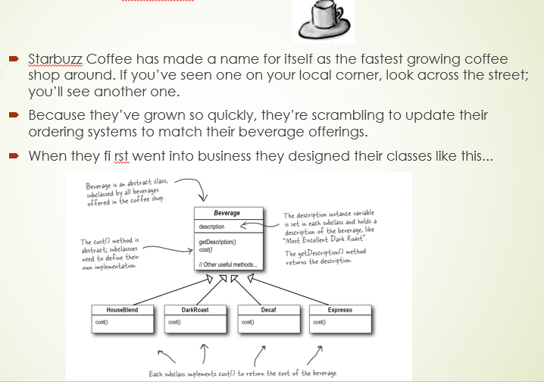

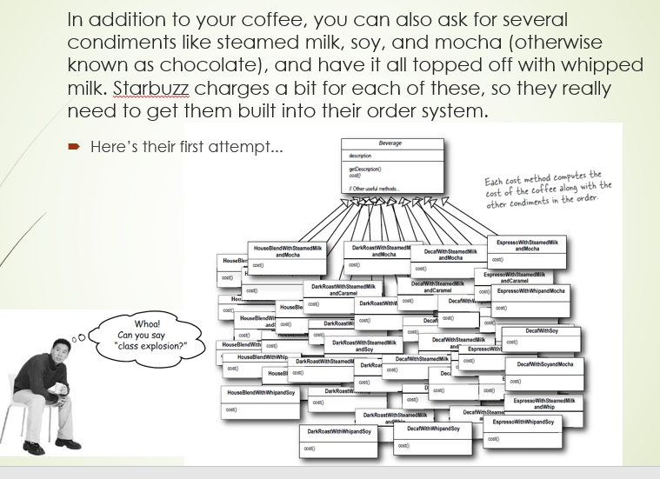

|  |  |
| --- | --- |
| **DecoratorStarbuzzEx.cs** | |
| **Line** | **Code** |
| **1**  **2**  **3**  **4**  **5**  **6**  **7**  **8**  **9**  **10**  **11**  **12**  **13**  **14**  **15**  **16**  **17**  **18**  **19**  **20**  **21**  **22**  **23**  **24**  **25**  **26**  **27**  **28**  **29**  **30**  **31**  **32**  **33**  **34**  **35**  **36**  **37**  **38**  **39**  **40**  **41**  **42**  **43**  **44**  **45**  **46**  **47**  **48**  **49**  **50**  **51**  **52**  **53**  **54**  **55**  **56**  **57**  **58**  **59**  **60**  **61**  **62**  **63**  **64**  **65**  **66**  **67** | **using** System;  **namespace** DecoratorStarbuzzEx {  **interface** Order {  **float** getPrice();  }  **class** Coffee:Order {  **public float** getPrice() {  **return** 5.0F;  }  }  **abstract class** Topping:Order {  **protected** Order order;  **abstract public float** getPrice();  **public** Topping(Order order) {  **this**.order = order;  }  }  **class** Cream:Topping {  **public** Cream(Order order):**base**(order) {  }  **override public float** getPrice() {  **return** order.getPrice() + 0.5F;  }  }  **class** Nut:Topping {  **public** Nut(Order order):**base**(order) {  }  **override public float** getPrice() {  **return** order.getPrice() + 1.0F;  }  }  **class** Strawberry:Topping {  **public** Strawberry(Order order):**base**(order) {  }  **override public float** getPrice() {  **return** order.getPrice() + 1.5F;  }  }  **class** Program {  **static void** Main(**string**[] args) {  Order order = **new** Coffee();  Console.Write("Want Cream?[Y/N]>>");  String answer = Console.ReadLine().ToUpper();  **if** (answer=="Y") order = **new** Cream(order);  Console.Write("Want Nut?[Y/N]>>");  answer = Console.ReadLine().ToUpper();  **if** (answer=="Y") order = **new** Nut(order);  Console.Write("Want Strawberry?[Y/N]>>");  answer = Console.ReadLine().ToUpper();  **if** (answer=="Y") order = **new** Strawberry(order);  Console.WriteLine("Thank You. {0:c} please", order.getPrice());  Console.ReadKey();  }  }  } |