**Exercise: *Builder Pattern***

**Duration:** 45 Minutes

**The Challenge:**

Consider the design below:

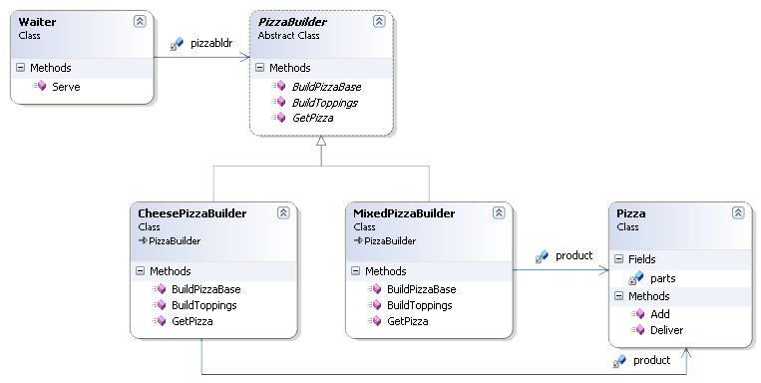

Answer the following questions:

1. Which design pattern the solution is adopting?

**Builder**

1. Base on the design pattern, try to find out who is what?
   1. Waiter is **Director**
   2. PizzaBuilder is **Builder**
   3. CheesePizzaBuilder and MixedPizzaBuilder are **Concretebuilder**
   4. Pizza is **product**
2. Code this design

Need a new factory and the exact implementation of the buttons and we can support the new OS.