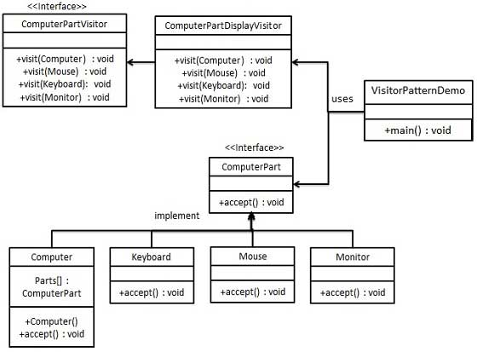

|  |  |
| --- | --- |
| **VisitorComputer** | |
| **Line** | **Code** |
| **1**  **2**  **3**  **4**  **5**  **6**  **7**  **8**  **9**  **10**  **11**  **12**  **13**  **14**  **15**  **16**  **17**  **18**  **19**  **20**  **21**  **22**  **23**  **24**  **25**  **26**  **27**  **28**  **29**  **30**  **31**  **32**  **33**  **34**  **35**  **36**  **37**  **38**  **39**  **40**  **41**  **42**  **43**  **44**  **45**  **46**  **47**  **48**  **49**  **50**  **51**  **52**  **53**  **54**  **55**  **56**  **57**  **58**  **59**  **60**  **61**  **62** | **using** System;  **namespace** VisitorComputerEx {  **interface** ComputerPart {  **void** Accept(ComputerPartVisitor computerPartVisitor);  }  **class** Keyboard : ComputerPart {  **public void** Accept(ComputerPartVisitor computerPartVisitor) {  computerPartVisitor.Visit(**this**);  }  }  **class** Monitor : ComputerPart {  **public void** Accept(ComputerPartVisitor computerPartVisitor) {  computerPartVisitor.Visit(**this**);  }  }  **class** Mouse : ComputerPart {  **public void** Accept(ComputerPartVisitor computerPartVisitor) {  computerPartVisitor.Visit(**this**);  }  }  **class** Computer {  ComputerPart[] parts;  **public** Computer() {  parts = **new** ComputerPart[] {  **new** Mouse(), **new** Keyboard(), **new** Monitor() };  }  **public void** Accept(ComputerPartVisitor computerPartVisitor) {  **foreach** (ComputerPart part **in** parts) {  part.Accept(computerPartVisitor);  }  }  }  **interface** ComputerPartVisitor {  **void** Visit(Mouse mouse);  **void** Visit(Keyboard keyboard);  **void** Visit(Monitor monitor);  }  **class** ComputerPartDisplayVisitor : ComputerPartVisitor {  **public void** Visit(Mouse mouse) {  Console.WriteLine("Accessing Mouse.");  }  **public void** Visit(Keyboard keyboard) {  Console.WriteLine("Accessing Keyboard.");  }  **public void** Visit(Monitor monitor) {  Console.WriteLine("Accessing Monitor.");  }  }  **class** Program {  **static void** Main(**string**[] args) {  Computer computer = **new** Computer();  computer.Accept(**new** ComputerPartDisplayVisitor());  Console.ReadKey();  }  }  } |