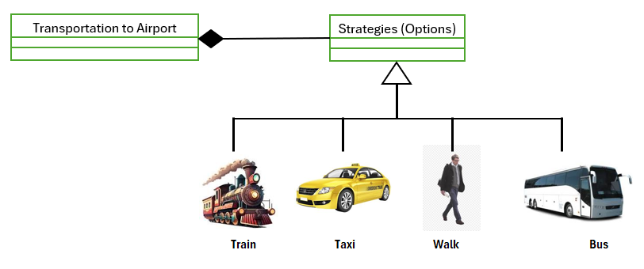
StrategyEx.java
Line | Code
1  2  3  4  5  6  7  8  9  10  11  12  13  14  15  16  17  18  19  20  21  22  23  24  25  26  27  28  29  30  31  32  33  34  35  36  37  38  39  40  41  42  43  44  45  46  47  48  49  50  51  52  53  54  55  56  57  58  59  60  61  62  63  64  65  66  67  68  69  70  71  72  73  74  75  76  77  78  79  80  81  82  83  84  85  86  87  88  89  90  91  92  93 | using System;  /*  Your Strategy Challenge:  ========================  You have 4 strategies to reach Airport from your office.  1) By Bus  2) By Taxi  3) By Train  4) Walking  Basically there 2 criteria to determine which strategy the program will select:  1) Time  2) Cost  Write a program to use Strategy Pattern. In the program you will prompt the  user about how important are those criteria, the program will select an  adequate stratery for the task.  */  namespace StrategyEx {  class Context {  //Context state  static public IStrategy byBus = new ByBus();  static public IStrategy byWalking = new ByWalking();  static public IStrategy byTrain = new ByTrain();  static public IStrategy byTaxi = new ByTaxi();  //Strategy aggregation  IStrategy strategy = null;  public IStrategy Strategy {  set {  strategy = value;  }  }  // Algorithm invokes a strategy method  public void GotoAirport() {  Console.Write("Going to airport ");  strategy.Transportation(this);  }  }  interface IStrategy {  void Transportation(Context c);  }  class ByBus : IStrategy {  public void Transportation(Context c) {  Console.WriteLine("by Bus");  }  }  class ByWalking : IStrategy {  public void Transportation(Context c) {  Console.WriteLine("by Walking");  }  }  class ByTrain : IStrategy {  public void Transportation(Context c) {  Console.WriteLine("by Train");  }  }  class ByTaxi : IStrategy {  public void Transportation(Context c) {  Console.WriteLine("by Taxi");  }  }  class Program {  static void Main(string[] args) {  Console.Write("Are you in hurry?>>[Y/n]");  bool time = Console.ReadLine().ToUpper() == "Y";  Console.Write("Is cost is you concern?>>[Y/n]");  bool cost = Console.ReadLine().ToUpper() == "Y";  //Ask from the user about cost and time  Context Trip = new Context();  if (cost) {//I am poor  if (time) {//I am in hurry  Trip.Strategy = Context.byBus;  } else {  Trip.Strategy = Context.byWalking;  }  } else {//Money is not my concern  if (time) {//I am in hurry  Trip.Strategy = Context.byTaxi;  } else {  Trip.Strategy = Context.byTrain;  }  }  Trip.GotoAirport();  Console.WriteLine();  Console.ReadKey();  }  }  }

