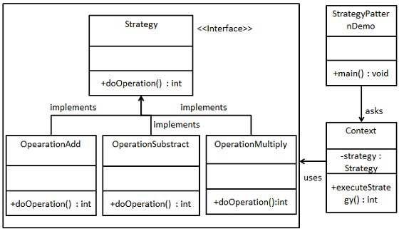

|  |  |
| --- | --- |
| **StrategyDemo.java** | |
| **Line** | **Code** |
| **1**  **2**  **3**  **4**  **5**  **6**  **7**  **8**  **9**  **10**  **11**  **12**  **13**  **14**  **15**  **16**  **17**  **18**  **19**  **20**  **21**  **22**  **23**  **24**  **25**  **26**  **27**  **28**  **29**  **30**  **31**  **32**  **33**  **34**  **35**  **36**  **37**  **38**  **39**  **40**  **41**  **42**  **43**  **44**  **45**  **46** | **using** System;  **namespace** Strategy {  **interface** Strategy {  **int** doOperation(**int** num1, **int** num2);  }  **class** OperationAdd : Strategy {  **public int** doOperation(**int** num1, **int** num2) {  **return** num1 + num2;  }  }  **class** OperationSubstract : Strategy {  **public int** doOperation(**int** num1, **int** num2) {  **return** num1 - num2;  }  }  **class** OperationMultiply : Strategy {  **public int** doOperation(**int** num1, **int** num2) {  **return** num1 * num2;  }  }  **class** Context {  **private** Strategy strategy;  **public** Context(Strategy strategy) {  **this**.strategy = strategy;  }  **public int** executeStrategy(**int** num1, **int** num2) {  **return** strategy.doOperation(num1, num2);  }  }  **class** Program {  **static void** Main(**string**[] args) {  Context context = **new** Context(**new** OperationAdd());  Console.WriteLine("10 + 5 = " + context.executeStrategy(10, 5));  context = **new** Context(**new** OperationSubstract());  Console.WriteLine("10 - 5 = " + context.executeStrategy(10, 5));  context = **new** Context(**new** OperationMultiply());  Console.WriteLine("10 * 5 = " + context.executeStrategy(10, 5));  Console.ReadKey();  }  }  } |