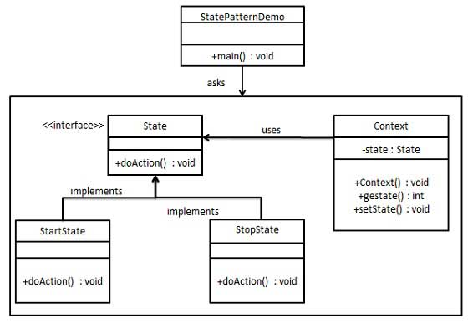

|  |  |
| --- | --- |
| **State** | |
| **Line** | **Code** |
| **1**  **2**  **3**  **4**  **5**  **6**  **7**  **8**  **9**  **10**  **11**  **12**  **13**  **14**  **15**  **16**  **17**  **18**  **19**  **20**  **21**  **22**  **23**  **24**  **25**  **26**  **27**  **28**  **29**  **30**  **31**  **32**  **33**  **34**  **35**  **36**  **37**  **38**  **39**  **40**  **41**  **42**  **43**  **44**  **45**  **46**  **47**  **48**  **49**  **50**  **51**  **52**  **53**  **54**  **55**  **56**  **57**  **58**  **59**  **60**  **61**  **62**  **63** | **using** System;  **namespace** State {  **interface** State {  **void** doAction(Context context);  }  **class** StartState : State {  **public void** doAction(Context context) {  Console.WriteLine("Player is in start state");  context.setState(**this**);  }  **public override string** ToString() {  **return** "Start State";  }  }  **class** StopState : State {  **public void** doAction(Context context) {  Console.WriteLine("Player is in stop state");  context.setState(**this**);  }  **public override string** ToString() {  **return** "Stop State";  }  }  **class** Context {  **private** State state;  **public** Context() {  state = **null**;  }  **public void** setState(State state) {  **this**.state = state;  }  **public** State getState() {  **return** state;  }  }  **class** Program {  **static void** Main() {  Context context = **new** Context();  StartState startState = **new** StartState();  startState.doAction(context);  Console.WriteLine(context.getState());  StopState stopState = **new** StopState();  stopState.doAction(context);  Console.WriteLine(context.getState());  Console.ReadKey();  }  }  } |