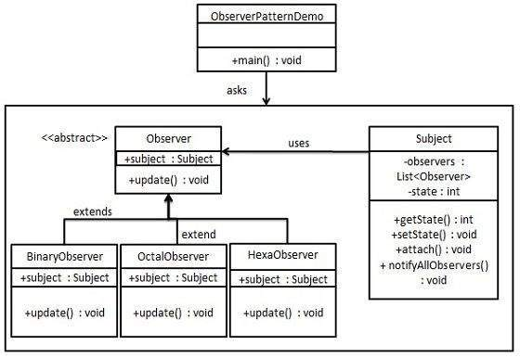

|  |  |
| --- | --- |
| **Observer** | |
| **Line** | **Code** |
| **1**  **2**  **3**  **4**  **5**  **6**  **7**  **8**  **9**  **10**  **11**  **12**  **13**  **14**  **15**  **16**  **17**  **18**  **19**  **20**  **21**  **22**  **23**  **24**  **25**  **26**  **27**  **28**  **29**  **30**  **31**  **32**  **33**  **34**  **35**  **36**  **37**  **38**  **39**  **40**  **41**  **42**  **43**  **44**  **45**  **46**  **47**  **48**  **49**  **50**  **51**  **52**  **53**  **54**  **55**  **56**  **57**  **58**  **59**  **60**  **61**  **62**  **63**  **64**  **65**  **66**  **67**  **68**  **69**  **70**  **71**  **72**  **73**  **74**  **75**  **76**  **77**  **78**  **79**  **80** | **using** System;  **using** System.Collections.Generic;  **using** System.Threading;  **namespace** Observer {  **class** Subject {  **private readonly** List<Observer> observers = **new** List<Observer>();  **private int** state;  **public int** getState() {  **return** state;  }  **public void** setState(**int** state) {  **this**.state = state;  notifyAllObservers();  }  **public void** attach(Observer observer) {  observers.Add(observer);  }  **public void** notifyAllObservers() {  **foreach** (Observer observer **in** observers) {  observer.update();  }  }  }  **abstract class** Observer {  **protected** Subject subject;  **public abstract void** update();  }  **class** BinaryObserver : Observer {  **public** BinaryObserver(Subject subject) {  **this**.subject = subject;  subject.attach(**this**);  }  **public override void** update() {  Console.WriteLine("Binary String: " +  Convert.ToString(subject.getState(), 2));  }  }  **class** OctalObserver : Observer {  **public** OctalObserver(Subject subject) {  **this**.subject = subject;  subject.attach(**this**);  }  **public override void** update() {  Console.WriteLine("Octal String: " +  Convert.ToString(subject.getState(), 8).ToUpper());  }  }  **class** HexaObserver : Observer {  **public** HexaObserver(Subject subject) {  **this**.subject = subject;  subject.attach(**this**);  }  **public override void** update() {  Console.WriteLine("Hex String: " +  Convert.ToString(subject.getState(), 16).ToUpper());  }  }  **class** Program {  **static void** Main() {  Subject subject = **new** Subject();  **new** HexaObserver(subject);  **new** OctalObserver(subject);  **new** BinaryObserver(subject);  Console.WriteLine("First state change: 15");  subject.setState(15);  Console.WriteLine("Second state change: 10");  subject.setState(10);  Console.ReadKey();  }  }  } |