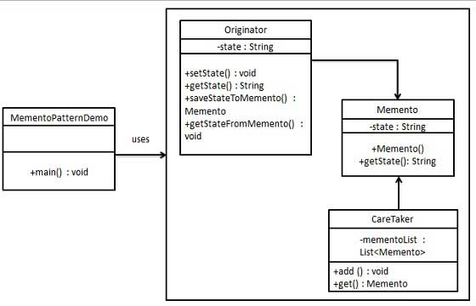

|  |  |
| --- | --- |
| **Memento** | |
| **Line** | **Code** |
| **1**  **2**  **3**  **4**  **5**  **6**  **7**  **8**  **9**  **10**  **11**  **12**  **13**  **14**  **15**  **16**  **17**  **18**  **19**  **20**  **21**  **22**  **23**  **24**  **25**  **26**  **27**  **28**  **29**  **30**  **31**  **32**  **33**  **34**  **35**  **36**  **37**  **38**  **39**  **40**  **41**  **42**  **43**  **44**  **45**  **46**  **47**  **48**  **49**  **50**  **51**  **52**  **53**  **54**  **55**  **56**  **57**  **58**  **59**  **60**  **61**  **62**  **63**  **64**  **65**  **66** | **using** System;  **using** System.Collections.Generic;  **namespace** Memento {  **class** Memento {  **private string** state;  **public** Memento(**string** state) {  **this**.state = state;  }  **public string** GetState() {  **return** state;  }  }  **class** Originator {  **private string** state;  **public void** SetState(String state) {  **this**.state = state;  }  **public string** GetState() {  **return** state;  }  **public** Memento saveStateToMemento() {  **return new** Memento(state);  }  **public void** getStateFromMemento(Memento memento) {  state = memento.GetState();  }  }  **class** CareTaker {  **private readonly** List<Memento> mementoList = **new** List<Memento>();  **public void** Add(Memento state) {  mementoList.Add(state);  }  **public** Memento **this**[**int** index] {  **get** {  **return** mementoList[index];  }  }  }  **class** Program {  **static void** Main(**string**[] args) {  Originator originator = **new** Originator();  CareTaker careTaker = **new** CareTaker();  originator.SetState("State #1");  originator.SetState("State #2");  careTaker.Add(originator.saveStateToMemento());  originator.SetState("State #3");  careTaker.Add(originator.saveStateToMemento());  originator.SetState("State #4");  Console.WriteLine("Current State: " + originator.GetState());  originator.getStateFromMemento(careTaker[0]);  Console.WriteLine("First saved State: " + originator.GetState());  originator.getStateFromMemento(careTaker[1]);  Console.WriteLine("Second saved State: " + originator.GetState());  Console.ReadKey();  }  }  } |