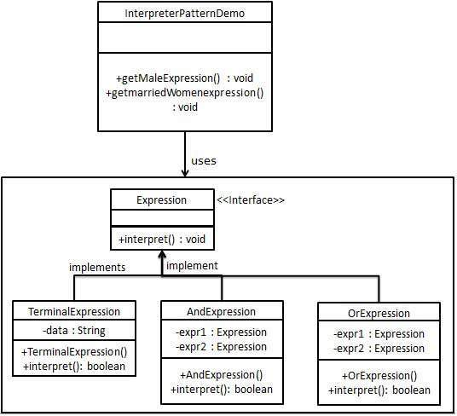

|  |  |
| --- | --- |
| **Interpreter** | |
| **Line** | **Code** |
| **1**  **2**  **3**  **4**  **5**  **6**  **7**  **8**  **9**  **10**  **11**  **12**  **13**  **14**  **15**  **16**  **17**  **18**  **19**  **20**  **21**  **22**  **23**  **24**  **25**  **26**  **27**  **28**  **29**  **30**  **31**  **32**  **33**  **34**  **35**  **36**  **37**  **38**  **39**  **40**  **41**  **42**  **43**  **44**  **45**  **46**  **47**  **48**  **49**  **50**  **51**  **52**  **53**  **54**  **55**  **56**  **57**  **58**  **59**  **60**  **61**  **62**  **63**  **64**  **65**  **66**  **67**  **68**  **69**  **70**  **71**  **72**  **73**  **74**  **75**  **76**  **77**  **78**  **79**  **80**  **81**  **82**  **83**  **84**  **85**  **86** | /*-----------------------------------------------------------------  Given a language, defines a representation for its grammar  along with an interpreter that uses the representation to  interpret sentences in the language.  This structural code demonstrates the Interpreter patterns,  which using a defined grammer, provides the interpreter that  processes parsed statements.  -------------------------------------------------------------------*/  **using** System;  **using** System.Collections;  **namespace** Interpreter {  **class** Context {  }  **public interface** Expression {  **bool** interpret(**string** context);  }  **class** TerminalExpression : Expression {  **private string** data;  **public** TerminalExpression(**string** data) {  **this**.data = data;  }  **public bool** interpret(**string** context) {  **return** context.Contains(data);  }  }  **public class** OrExpression : Expression {  **private** Expression expr1 = **null**;  **private** Expression expr2 = **null**;  **public** OrExpression(Expression expr1, Expression expr2) {  **this**.expr1 = expr1;  **this**.expr2 = expr2;  }  **public bool** interpret(**string** context) {  **return** expr1.interpret(context) || expr2.interpret(context);  }  }  **public class** AndExpression : Expression {  **private** Expression expr1 = **null**;  **private** Expression expr2 = **null**;  **public** AndExpression(Expression expr1, Expression expr2) {  **this**.expr1 = expr1;  **this**.expr2 = expr2;  }  **public bool** interpret(**string** context) {  **return** expr1.interpret(context) && expr2.interpret(context);  }  }  **public class** InterpreterDemo {  //Rule: Robert and John are male  **public static** Expression getMaleExpression() {  Expression robert = **new** TerminalExpression("Robert");  Expression john = **new** TerminalExpression("John");  **return new** OrExpression(robert, john);  }  //Rule: Julie is a married women  **public static** Expression getMarriedWomanExpression() {  Expression julie = **new** TerminalExpression("Julie");  Expression married = **new** TerminalExpression("Married");  **return new** AndExpression(julie, married);  }  **static void** Main() {  Expression isMale = getMaleExpression();  Expression isMarriedWoman = getMarriedWomanExpression();  Console.WriteLine("John is male? " + isMale.interpret("John"));  Console.WriteLine("Julie is a married women? " +  isMarriedWoman.interpret("Married Julie"));  Console.ReadKey();  }  }  } |