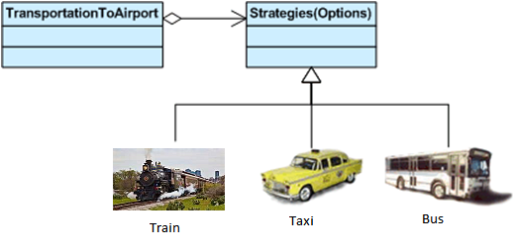

|  |  |
| --- | --- |
| **StrategyEx.java** | |
| **Line** | **Code** |
| **1**  **2**  **3**  **4**  **5**  **6**  **7**  **8**  **9**  **10**  **11**  **12**  **13**  **14**  **15**  **16**  **17**  **18**  **19**  **20**  **21**  **22**  **23**  **24**  **25**  **26**  **27**  **28**  **29**  **30**  **31**  **32**  **33**  **34**  **35**  **36**  **37**  **38**  **39**  **40**  **41**  **42**  **43**  **44**  **45**  **46**  **47**  **48**  **49**  **50**  **51**  **52**  **53**  **54**  **55**  **56**  **57**  **58**  **59**  **60**  **61**  **62**  **63**  **64**  **65**  **66**  **67**  **68**  **69**  **70**  **71**  **72**  **73**  **74**  **75**  **76**  **77**  **78**  **79**  **80**  **81**  **82**  **83**  **84**  **85**  **86**  **87**  **88**  **89**  **90**  **91**  **92**  **93** | **using** System;  /*  Your Strategy Challenge:  ========================  You have 4 strategies to reach Airport from your office.  1) By Bus  2) By Taxi  3) By Train  4) Walking  Basically there 2 criteria to determine which strategy the program will select:  1) Time  2) Cost  Write a program to use Strategy Pattern. In the program you will prompt the  user about how important are those criteria, the program will select an  adequate stratery for the task.  */  **namespace** StrategyEx {  **class** Context {  //Context state  **static public** IStrategy byBus = **new** ByBus();  **static public** IStrategy byWalking = **new** ByWalking();  **static public** IStrategy byTrain = **new** ByTrain();  **static public** IStrategy byTaxi = **new** ByTaxi();  //Strategy aggregation  IStrategy strategy = **null**;  **public** IStrategy Strategy {  **set** {  strategy = **value**;  }  }  // Algorithm invokes a strategy method  **public void** GotoAirport() {  Console.Write("Going to airport ");  strategy.Transportation(**this**);  }  }  **interface** IStrategy {  **void** Transportation(Context c);  }  **class** ByBus : IStrategy {  **public void** Transportation(Context c) {  Console.WriteLine("by Bus");  }  }  **class** ByWalking : IStrategy {  **public void** Transportation(Context c) {  Console.WriteLine("by Walking");  }  }  **class** ByTrain : IStrategy {  **public void** Transportation(Context c) {  Console.WriteLine("by Train");  }  }  **class** ByTaxi : IStrategy {  **public void** Transportation(Context c) {  Console.WriteLine("by Taxi");  }  }  **class** Program {  **static void** Main(**string**[] args) {  Console.Write("Are you in hurry?>>[Y/n]");  **bool** time = Console.ReadLine().ToUpper() == "Y";  Console.Write("Is cost is you concern?>>[Y/n]");  **bool** cost = Console.ReadLine().ToUpper() == "Y";  //Ask from the user about cost and time  Context Trip = **new** Context();  **if** (cost) {//I am poor  **if** (time) {//I am in hurry  Trip.Strategy = Context.byBus;  } **else** {  Trip.Strategy = Context.byWalking;  }  } **else** {//Money is not my concern  **if** (time) {//I am in hurry  Trip.Strategy = Context.byTaxi;  } **else** {  Trip.Strategy = Context.byTrain;  }  }  Trip.GotoAirport();  Console.WriteLine();  Console.ReadKey();  }  }  } |